1. How many usernames contain the letter A?

SELECT COUNT(*)

FROM Customer

WHERE username LIKE '%A%';

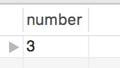 1 Row Returned

2. What is the average journey length, in seconds?

SELECT AVG(TIMESTAMPDIFF(second, startTime, endTime)) AS 'average length'

FROM Journey;

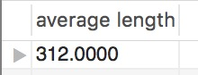1 Row Returned

3. List the stations on the Eastern line (excluding City), in outbound order.

SELECT name AS 'station'

FROM Station

WHERE line=3

ORDER BY sequence ASC;

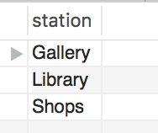 3 Rows Returned

4. On which day of the week (Monday, Tuesday etc.) are the most journeys made?

SELECT DATE_FORMAT(startTime, '%W') AS 'day'

FROM Journey

GROUP BY DATE_FORMAT(startTime, '%W')

ORDER BY COUNT(DATE_FORMAT(startTime, '%W')) DESC

LIMIT 1;

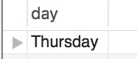 1 Row Returned

5. List any stations at which no passenger has started or ended a journey. Show the station id and name.

SELECT id AS 'station id',name AS 'station name'

FROM Station

WHERE id NOT IN (SELECT startStation FROM Journey)

AND id NOT IN (SELECT endStation FROM Journey);

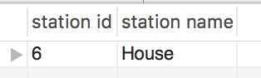 1 Row Returned

6. List the details of each journey, along with its cost.

SELECT a.*, CASE WHEN b.zone!=c.zone THEN '2$'

WHEN b.zone=2 AND c.zone=2 AND b.line!=c.line THEN '3$'

ELSE '1$'

END AS 'cost'

FROM Journey AS a INNER JOIN Station AS b INNER JOIN Station AS c ON a.startStation=b.id AND a.endStation=c.id

ORDER BY a.id;

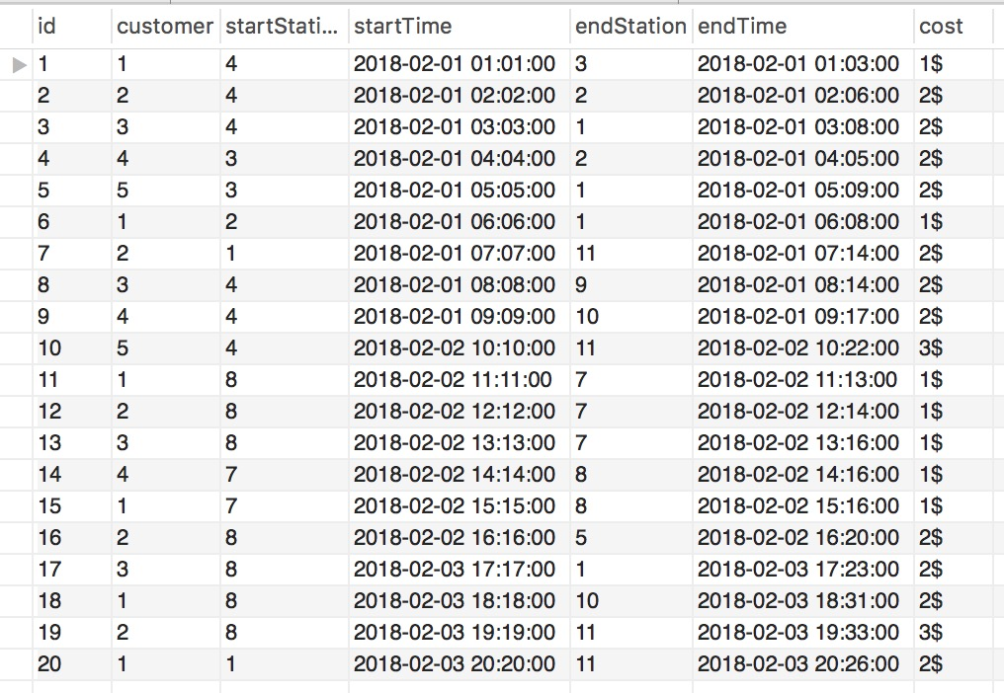

20 Rows Returned

7. List the station ids, along with the number of journeys that started or stopped at each station.

SELECT Station.id AS 'station id', COUNT(Journey.id) AS 'number'

FROM Journey RIGHT OUTER JOIN Station ON Station.id=Journey.startStation OR Station.id=Journey.endStation

GROUP BY Station.id;

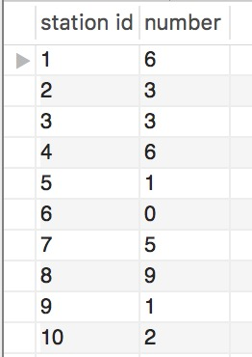 11 Rows Returned

8. List the journeys that ended at the last station on the line. (the station with the highest sequence number for a line)

SELECT *

FROM Journey

WHERE endStation IN

(SELECT id FROM Station

WHERE sequence IN (SELECT MAX(sequence) FROM Station WHERE line=1) AND line=1

OR sequence IN (SELECT MAX(sequence) FROM Station WHERE line=2) AND line=2

OR sequence IN (SELECT MAX(sequence) FROM Station WHERE line=3) AND line=3)

ORDER BY id;

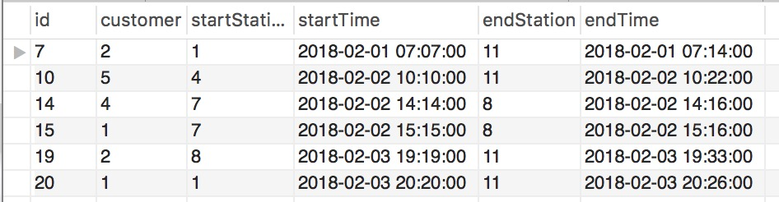

6 Rows Returned

9. For each journey, show how many stations it passed through. (Count the end station but not the start station.)

SELECT a.*, CASE WHEN b.line!=c.line

THEN b.sequence + c.sequence

ELSE ABS(CAST(b.sequence AS SIGNED)- CAST(c.sequence AS SIGNED))

END AS 'number'

FROM Journey AS a INNER JOIN Station AS b INNER JOIN Station AS c ON a.startStation=b.id AND a.endStation=c.id;

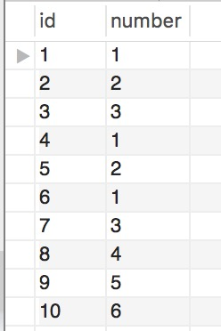20 Rows Returned

10. List the usernames of customers who have travelled on all lines.

SELECT username

FROM Customer

WHERE id IN (SELECT Journey.customer

FROM Station INNER JOIN Journey ON Station.id=Journey.startStation OR Station.id=Journey.endStation INNER JOIN Line ON Line.id=Station.line

GROUP BY Journey.customer

HAVING COUNT(DISTINCT Line.id)=3);

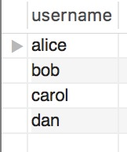 4 Rows Returned